**F74046129 資訊一乙 孫譽 Project 3 AngryBird**

遊戲功能:

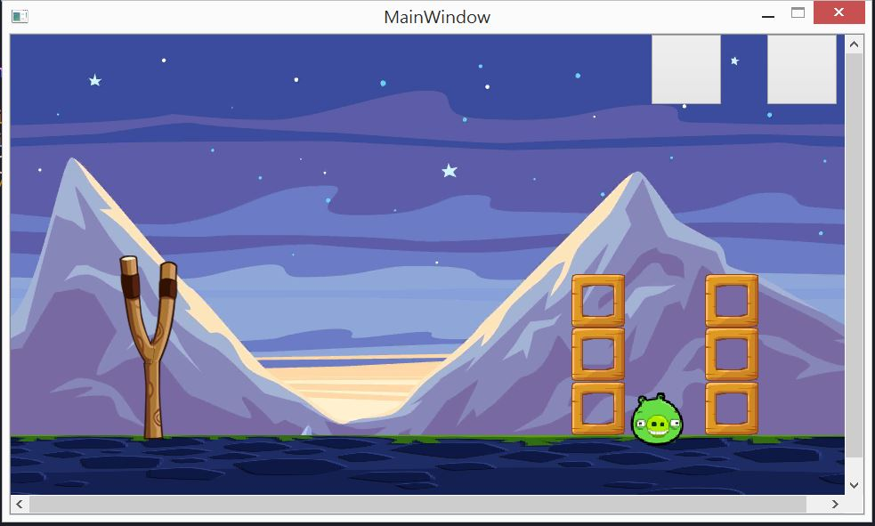

可以…用鳥丟 豬.

四種不同功能的鳥!

紅鳥:一般

黃鳥:按下按鍵2 就可以加速

黑鳥:按下按鍵3 垂直下墜攻擊

白鳥:按下按鍵4 就會隱形

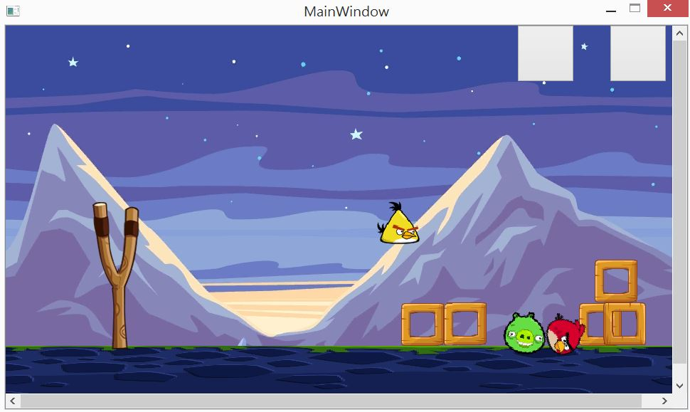

最右上角按鍵為EXIT

在他左邊的是RESTART!

UML Diagram

|  |
| --- |
| MainWindow |
| -scene: QGraphicsScene *  -world: b2World *  -itemList : QList<GameItem *>  -birdlist: QList<GameItem *>  -timer:QTimer  -exit : QPushButton *  -restart :QPushButton *  -v1,v2,v3 :int  -repeat,b,count:int  -g_worldsize,g_windowsize : static QSizeF |
| +<<explicit>> MainWindow(parent :QWidget * = 0 ):void  +~MainWindow()  +showEvent(QShowEvent*) :void  +eventFilter(QObject *,event:QEvent):bool  +closeEvent(QCloseEvent*):void  +pt:QPointF  +nice : QMediaPlayer *  +res : void |
|  |
| GameItem: inherit QObject |
| +g_body: b2Body *  +g_pixmap: QGraphicsPixmapItem  +g_size: QSizeF  +g_world: b2World *  +g_worldsize: static QSizeF  +g_windowsize: static QSizeF  +GameItem(world: b2World *)  +~GameItem()  +setGlobalSize(worldsize:QSizeF, windowsize: QSizeF): static void  +<<slots>>paint(): void |

|  |
| --- |
| Bird: inherit GameItem |
| + Bird(float x, float y, float radius, QTimer *timer, QPixmap pixmap, b2World *world, QGraphicsScene *scene);  +skill(1) :void  +skill(2):void  +skill(3):void |
|  |

|  |
| --- |
| Wood:inherit GameItem |
| + Wood(float x, float y, float w,float h, QTimer *timer, QPixmap pixmap, b2World *world, QGraphicsScene *scene); |